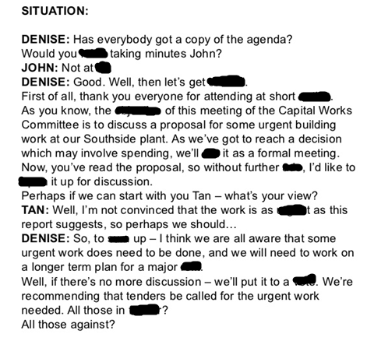

favour, mind , all, vote , sum , run , put , objective , notice , going , open , urgent , profit

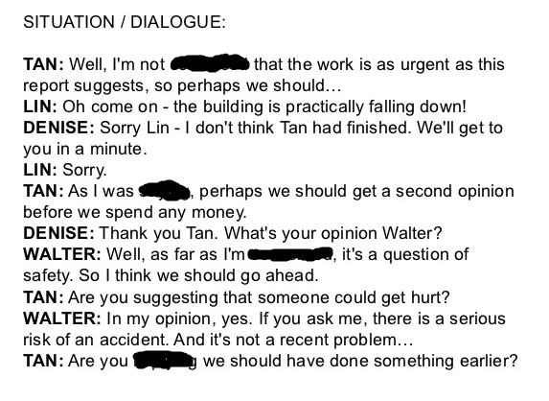

Saying , Convinced ,implying , concerned